**CCDC Earth Engine Documentation:**

<https://gee-ccdc-tools.readthedocs.io/en/latest/>

There are 3 steps needed in order to run the CCDC algorithm in Earth Engine. First the “Submit CCDC” part which conducts change detection on the study area within the specified time frame. This part was run using code (“ROP Project CCDC Code” below) as the web app does not allow you to use shapefiles and only lets you draw areas of interest. The next part is to “Classify CCDC Segments” which uses the training data we created and a machine learning classifier (such as random forest) to classify each CCDC segment of the pixels within the study area. This part was run using the web app (“Classify CCDC Segments Web App” below). The last part is to classify the land use land cover of each pixel based on their time series segments. This is done using the web app (“CCDC Classify Landuse Web App”) by inputting the previously classified segments, choosing which dates to classify and inputting the associated land use land cover names with a colour palette.

**ROP Project CCDC Code:**

<https://code.earthengine.google.com/dc687d227e740858e064f26e4f4b42fd>

**Web Apps:**

Submit CCDC Web App (web app only works on user drawn areas, can’t use defined study areas such as shapefiles):

<https://code.earthengine.google.com/?scriptPath=users%2Fparevalo_bu%2Fgee-ccdc-tools%3AAPPS%2Fsubmit_ccdc>

Classify CCDC Segments Web App:

<https://code.earthengine.google.com/?scriptPath=users%2Fparevalo_bu%2Fgee-ccdc-tools%3AAPPS%2Fclassify_app>

CCDC Classify Landuse Web App:

<https://code.earthengine.google.com/?scriptPath=users%2Fparevalo_bu%2Fgee-ccdc-tools%3AAPPS%2Flandcover_app>

Current Land Use List (For Web App Input):

Agricultural, Commercial-Industrial, Coniferous Forest, Deciduous Forest, Developed Barren, Herbaceous Wetland, High Density Residential, Low Density Residential, Manicured Grassland, Meadow, Medium Density Residential, Mixed Forest, Natural Barren, Shrubland, Water, Woody Wetland

Current Land Use Color Codes (For Web App Input):

#800000, #808080, #483d8b, #008080, #b8860b, #000080, #FF7F50, #8fbc8f, #8b008b, #ff0000, #ffd700, #1a6312, #8a2be2, #00ff7f, #0000FF, #ff0090

Change Class Name:

Value

Example Input of “CCDC Classify Landuse Web App”:

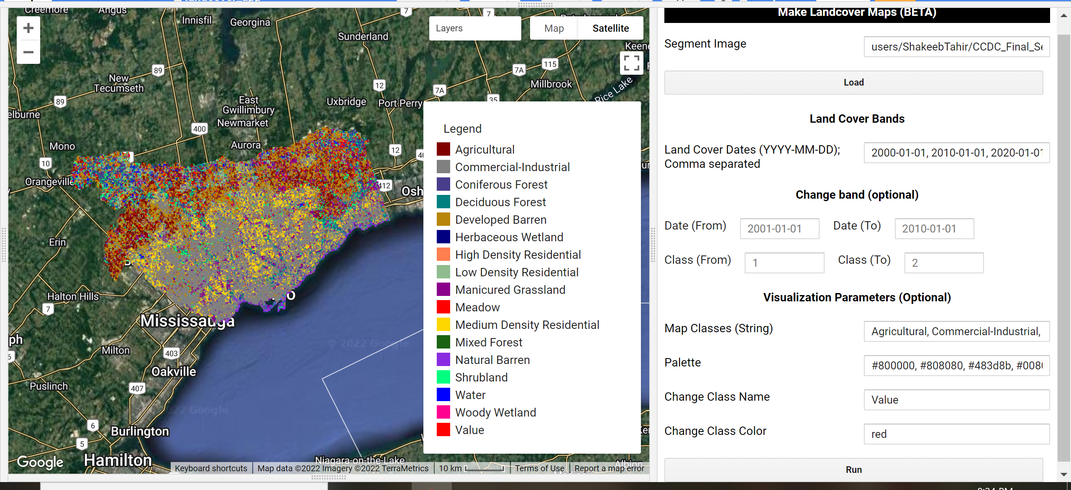

**Assets:**

CCDC Submit Web App Asset (used in Classify CCDC Segments Web App):

<https://code.earthengine.google.com/?asset=users/ShakeebTahir/CCDC_Final>

Classified CCDC Segments Asset (used in Classify Landuse Web App):

<https://code.earthengine.google.com/?asset=users/ShakeebTahir/CCDC_Final_Segments>